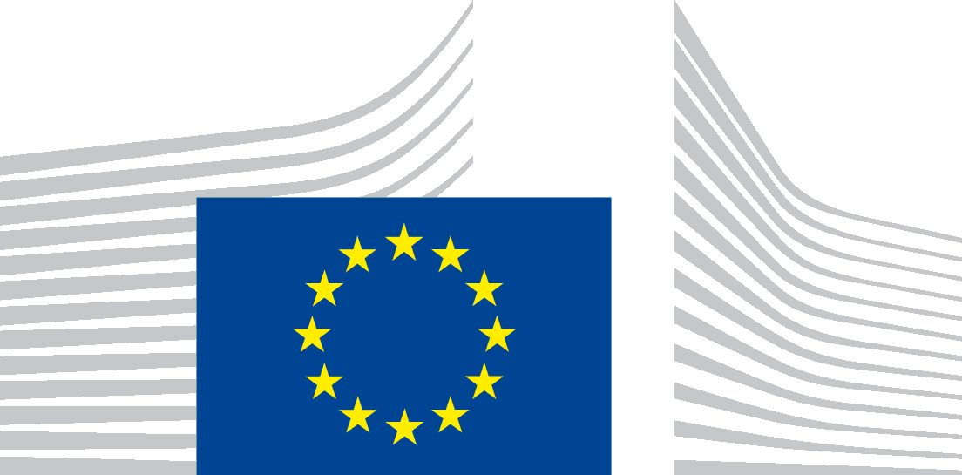 | EUROPEAN COMMISSION  DIRECTORATE-GENERAL  ENVIRONMENT  Directorate A - Green Economy  ENV.A.1 - Eco-Innovation & Circular Economy
EMAS Awards Evaluation Questionnaire 2015
Theme: “Eco-Innovation”
Criteria | Brief, clear description of the Eco-Innovation measures | Jury evaluation  (Jury’s justification for assigning the score for each criterion)  THIS COLUMN IS RESERVED FOR THE JURY AND SHOULD NOT BE COMPLETED BY THE APPLICANT | Points available  (max) | Points achieved  THIS COLUMN IS RESERVED FOR THE JURY AND SHOULD NOT BE COMPLETED BY THE APPLICANT
Main Criteria |  |  | Max. 70 points
1.“Innovativeness” of the environmental innovation  - How did the organisation improve its performance in its core business through eco-innovation?  - Is it a one-off initiative or a continuous process of innovation?  - How does the innovation add environmental and/or economic value to the organisation?  - How willing were organisations to change their business model? |  |  | Max. 35 points  Guidelines  Excellent (28-35 pts)  Good (20-27 pts)  Average (10-19 pts)  Below average (0-9 pts)
2. Improvement in environmental performance resulting from the innovative measure  - Environmental statement  - Eco-innovation effects on EMAS environmental core (performance) indicators:  - energy efficiency  - material efficiency  - waste  - biodiversity  - emissions  - water |  |  | Max. 35 points  Guidelines  Excellent (28-35 pts)  Good (20-27 pts)  Average (10-19 pts)  Below average (0-9 pts)
Subtotal - Main Criteria
Supporting Criteria |  |  | Max. 30 points
- Supply Chain and Customers  - Has the organisation actively involved its suppliers and/or customers when implementing actions to improve the environmental performance of its products and services? If yes, in what way?  - Did the organisation use a life cycle perspective to improve the eco-design of its products/services and did it involve its suppliers/customers in doing so? If yes, in what way? |  |  | Max. 5 points  Guidelines  Excellent (5 pts)  Good (3-4 pts)  Average (1-2 pts)  Below average (0 pts)
- Stakeholder Engagement /Employee Involvement  - In what way has the organisation taken into account the opinions of its (main) stakeholder(s) in, for example, screening environmental aspects, drafting the environmental statement, external communication activities etc.?  - How has the organisation involved its employees in the eco-innovation process? |  |  | Max. 5 points  Guidelines  Excellent (5 pts)  Good (3-4 pts)  Average (1-2 pts)  Below average (0 pts)
- Communication and Transparency  - Has the organisation tailored its EMAS environmental statement to the interests and information needs of its different target audiences (e.g. by drafting different sections of the environmental statement)?  - Has the organisation taken further actions (besides publication alone) to communicate the contents of the environmental statement to different external stakeholders? |  |  | Max. 5 points  Guidelines  Excellent (5 pts)  Good (3-4 pts)  Average (1-2 pts)  Below average (0 pts)
- Indirect environmental aspects of the product/service range  - Has the organisation carried out a life cycle assessment in order to identify and assess the direct and indirect environmental aspects?  - Did the organisation use a life cycle assessment approach to determine or revise its environmental objectives?  - Is the communication of the environmental performance of the organisation’s products/services based on the results of a life cycle assessment (study)? |  |  | Max. 5 points  Guidelines  Excellent (5 pts)  Good (3-4 pts)  Average (1-2 pts)  Below average (0 pts)
- Replication potential and benchmarking  - To what extent could the eco-innovation be copied / implemented or further developed by other actors / other organisations in the same sector or other sectors?  - To what extent has the implemented eco-innovation demonstrated market-readiness (successful examples are mentioned under eco-innovation market replication initiative)?  - To what extent did the eco-innovation stimulate additional investment(s)?  - To what extent did the organisation compare its environmental performance with relevant benchmarks of the sector (i.e. EMAS SRDs, BREF documents, sectoral environmental reports etc.)?  - What were the novelty and origins of the implemented eco-innovation(s)? |  |  | Max. 5 points  Guidelines  Excellent (5 pts)  Good (3-4 pts)  Average (1-2 pts)  Below average (0 pts)
- Organisational commitment  - How do the environmental issues and the commitments to environmental performance improvements influence the organisation’s business model and organisational decision making?  - Are environmental aspects of the organisation a key factor when defining its competitive business strategy?  - Are environmental concerns a common area of all the organisation’s business departments?  - Did the organisation’s commitment to environmental performance improvements have a significant effect on one or more of the following aspects: company's value proposition, target customer-groups, distribution channels, customer relationships, core capabilities, partner network; and cost and revenue structure? |  |  | Max. 5 points  Guidelines  Excellent (5 pts)  Good (3-4 pts)  Average (1-2 pts)  Below average (0 pts)
Subtotal - Supporting Criteria
Subtotal - Main Criteria (see above)
Total of points scored by: (please insert the organization name) |  |  | Max. 100 points in total

Additional comments
Applicant
(Please add any additional comments that support your application)
Jury
(Please add any additional comments that support your evaluation)
THIS FIELD IS RESERVED FOR THE JURY AND SHOULD NOT BE COMPLETED BY THE APPLICANT

